Experiment No:2

# Aim: - To study the process and intricacies of Amplitude modulation.

# Hardware/Software used: -

An online platform which provides virtual breadboard, capacitors, resistors, transistors, oscillators, function generator (to generate sine wave), power supply, etc. required for constructing a circuit.

# Theory: -

**AMPLITUDE MODULATION: -**

Modulation is defined as the process by which some characteristics of a carrier signal is varied in accordance with a modulating signal. The base band signal is referred to as the modulating signal and the output of the modulation process is called as the modulation signal.

Amplitude modulation is defined as the process in which is the amplitude of the carrier wave is varied about a means values linearly with the base band signal. The envelope of the modulating wave has the same shape as the base band signal provided the following two requirements are satisfied

1. The carrier frequency fc must be much greater then the highest frequency components fm of the message signal m (t) i.e. fc >> fm
2. The modulation index must be less than unity. if the modulation index is greater than unity, the carrier wave becomes over modulated.

# Circuit diagram:

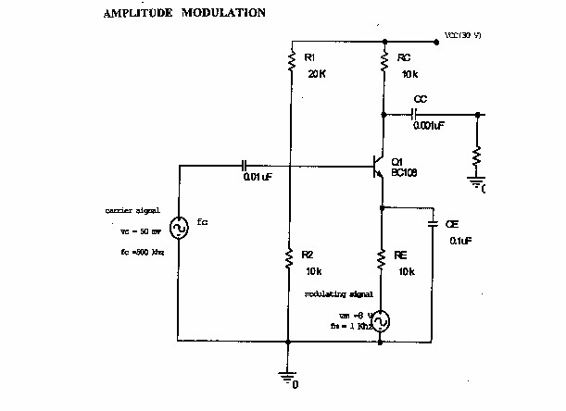

***Fig 1-1 Amplitude modulation***

***Fig 1***

***-***

***2***

***Amplitude modulation***

***model graph***

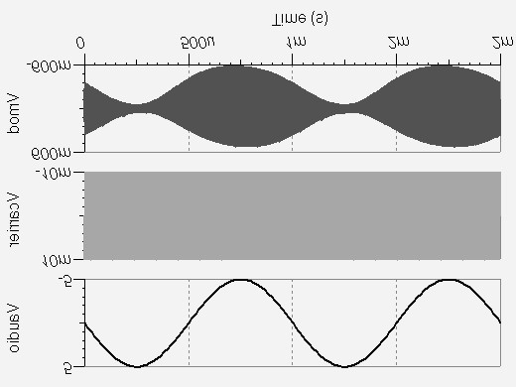

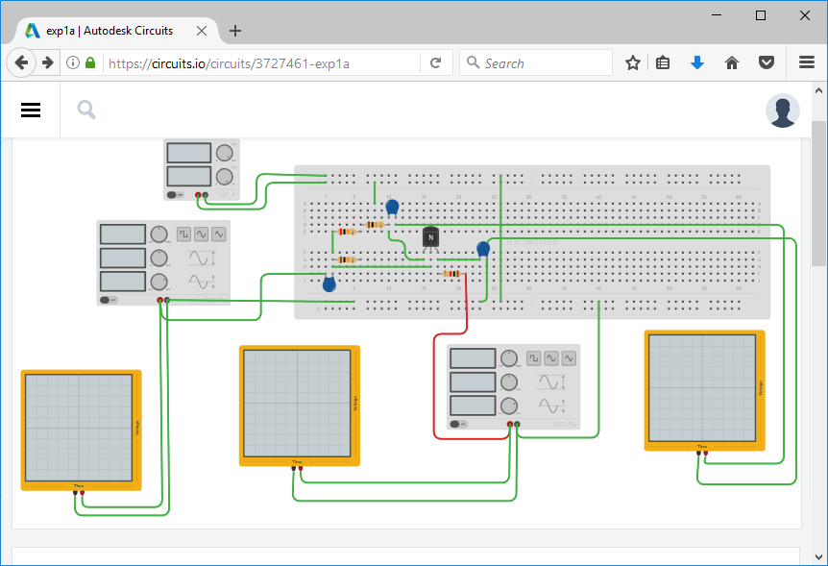

***Fig 1-1 Amplitude modulation as created in circuits.io***

# Design procedure:

Given:

VC = 1.5V,

fc = 500 KHz,

fm = 1KHz.

Set modulating voltage Vm = 5 V.

Emax = 1.6 V, Emin = 0.7 V

*E*max- *E* min

Modulation index (m) = x 100= 39.13%

*E*max + *E* min

# Test procedure: -

1. The circuit connection is made as shown in the circuit.
2. The power supply is connected to the collector of the Transistor.
3. Modulated Output is taken from the collector of the Transistor.
4. Calculate Emax and Emin from the output waveform.

# Output:

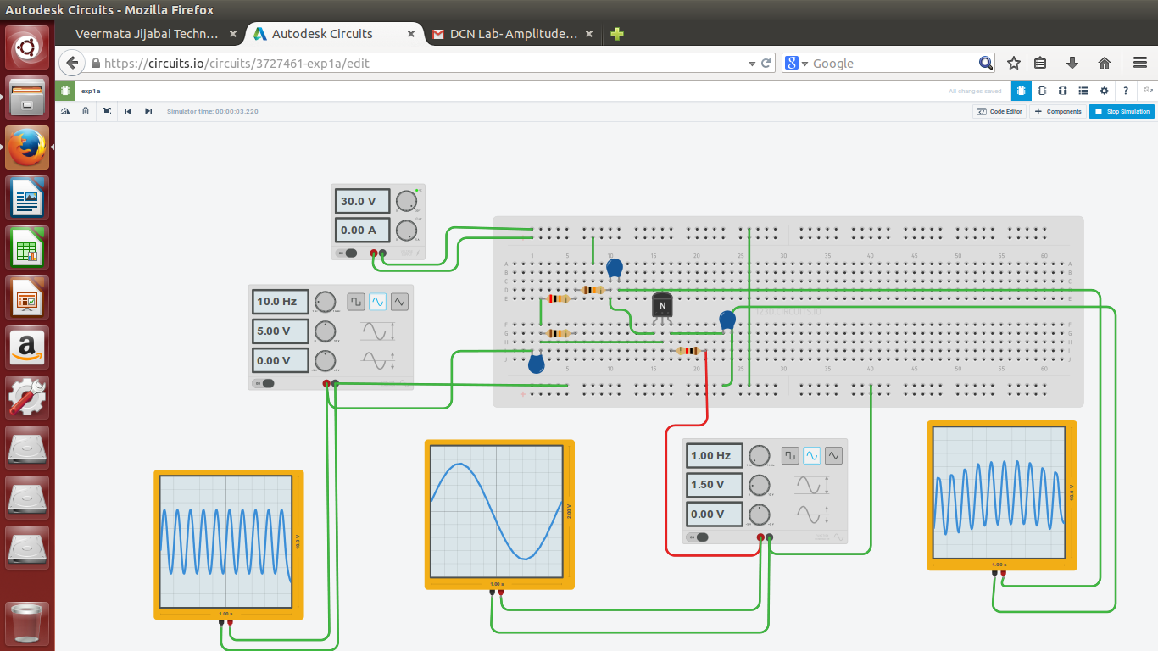

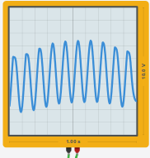

# Conclusion: -

Thus,

* The basics of amplitude modulation along with its use, advantages and pitfalls were studied.
* The circuit diagram was analysed and a virtual circuit which replicates the given circuit diagram was constructed over a breadboard interface provided by circuits.io
* The values of various components of circuit were changed in order to meet the constraints of the platform and to fasten up the *Simulation time* of the circuit.